**Project Design Phase-II**

**Data Flow Diagram & User Stories**

| Date | 31 January 2025 |
| --- | --- |
| Team ID | LTVIP2025TMID55575 |
| Project Name | SHOPSMART-DIGITAL GROCERY STORE EXPERIENCE |
| Maximum Marks | 4 Marks |

**Data Flow Diagrams:**

A Data Flow Diagram (DFD) is a traditional visual representation of the information flows within a system. A neat and clear DFD can depict the right amount of the system requirement graphically. It shows how data enters and leaves the system, what changes the information, and where data is stored.



**Example:** [**(Simplified)**](https://developer.ibm.com/patterns/visualize-unstructured-text/)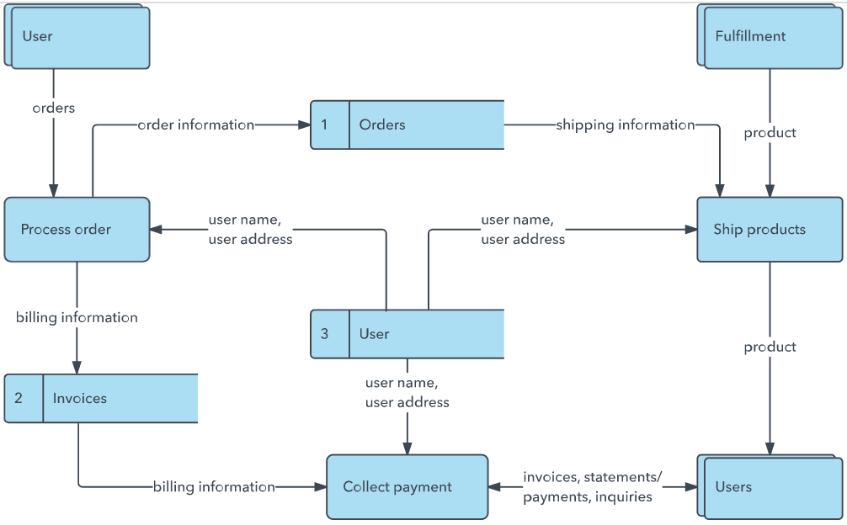

**User Stories**

Use the below template to list all the user stories for the product.

| **User Type** | **Functional Requirement (Epic)** | **User Story Number** | **User Story / Task** | **Acceptance criteria** | **Priority** | **Release** |
| --- | --- | --- | --- | --- | --- | --- |
| Customer (Mobile user) | Registration | USN-1 | As a user, I can register for the application by entering my email, password, and confirming my password. | I can access my account / dashboard | High | Sprint-1 |
|  |  | USN-2 | As a user, I will receive confirmation email once I have registered for the application | I can receive confirmation email & click confirm | High | Sprint-1 |
|  |  | USN-3 | As a user, I can register for the application through Facebook | I can register & access the dashboard with Facebook Login | Low | Sprint-2 |
|  |  | USN-4 | As a user, I can register for the application through Gmail | Able to log in using Gmail | Medium | Sprint-1 |
|  | Login | USN-5 | As a user, I can log into the application by entering email & password | Login successful and redirected to dashboard. | High | Sprint-1 |
|  | Browse Products | USN-6 | As a user, I can browse categories and grocery items. | Products are visible and filterable. | High | Sprint-1 |
|  | Add to Cart | USN-7 | As a user, I can add items to the shopping cart. | Cart gets updated with selected items. | High | Sprint-1 |
|  | Place Order | USN-8 | As a user, I can place an order with selected items and address. | Order placed and order ID received. | High | Sprint-2 |
|  | Make Payment | USN-9 | As a user, I can pay through UPI, card or COD | Payment confirmation received. | High | Sprint-2 |
|  | Order Tracking | USN-10 | As a user, I can track the order status after checkout. | Order shows live status ( Packed,Shipped,Delivered ) | Medium | Sprint-2 |
|  | Ratings and Reviews | USN-11 | As a user, I can rate and review purchased products. | Submitted ratings are visible to other users. | Low | Sprint-3 |
|  | Offers and Coupons | USN-12 | As a user, I can view and apply offers or coupon codes. | Discounts are applied at checkout if valid. | Medium | Sprint-3 |
| Customer (Web user) | Registration and Login | USN-13 | As a web user, I can register and log in via web browser. | Able to access dashboard on the web. | High | Sprint-1 |
|  | Browse and Filter Products | USN-14 | As a web user, I can search and filter grocery items easily. | Filter and sort options work properly. | High | Sprint-1 |
|  | Manage Cart | USN-15 | As a web user, I can manage items in my cart. | Add/remove/update items easily | High | Sprint-1 |
|  | Checkout | USN-16 | As a web user, I can complete my purchase with secure payment. | Order is placed with confirmation. | High | Sprint-2 |
|  | Order History | USN-17 | As a web user, I can view my past orders and invoices. | Previous order list shown with details. | Medium | Sprint-2 |
| Customer Care Executive | View Customer Complaints | USN-18 | As a care executive, I can view and reply to customer complaints. | Messages appear in support dashboard. | High | Sprint-2 |
|  | Live Chat Support | USN-19 | As a care executive, I can chat live with customers for help. | Real-time messaging works properly | Medium | Sprint-3 |
|  | Refund Handling | USN-20 | As a care executive, I can initiate refunds based on order ID. | Refund status updates are tracked. | Medium | Sprint-3 |
| Administrator | Manage Users | USN-21 | As an admin, I can view and manage registered users. | User list, search, block/unblock available. | High | Sprint-1 |
|  | Inventory Management | USN-22 | As an admin, I can add/update/delete product listings. | Product catalog is updated accordingly. | High | Sprint-1 |
|  | Order Management | USN-23 | As an admin, I can view, edit, and track all customer orders. | Admin panel reflects real-time order status. | High | Sprint-2 |
|  | Offer Management | USN-24 | As an admin, I can create or disable promo codes. | Active offers appear for users. | Medium | Sprint-2 |
|  | Analytics and Reports | USN-25 | As an admin, I can view sales and traffic reports. | Graphs and stats are correctly generated. | Medium | Sprint-3 |

**FLOW DIAGRAM:**

